**REPORT**

**TOPIC**

**Employee Performance in a Company**



**Table of Contents**

**Introduction** 3

**Challenges** 3

**Methodology** 4

**Question and Ans** 12

**Enhancing Performance Rating** 13

**Result** 13

**Conclusion** 14

**Reference** 14

## **Introduction**

Employee performance in a company is a cornerstone of organizational success. It reflects how effectively employees execute their responsibilities, achieve goals, and contribute to the company’s overall objectives. High-performing employees not only drive productivity and innovation but also create a positive workplace culture that supports long-term growth and competitiveness.

In modern organizations, employee performance is influenced by various factors such as motivation, skill development, leadership quality, and access to resources. Companies often implement structured performance management systems to monitor, evaluate, and enhance employee contributions. These systems typically include setting clear expectations, providing regular feedback, and aligning individual objectives with organizational goals.

By investing in performance management, companies can identify strengths and areas for improvement among their workforce, foster professional development, and ensure that employees remain engaged and committed to the company’s success. Recognizing and rewarding exceptional performance is equally critical in sustaining morale and encouraging continuous improvement. In essence, managing employee performance effectively is key to maintaining a competitive edge in today’s dynamic business environment.

## **Challenges**

Employee performance in a company is often influenced by a range of challenges that can hinder productivity and overall organizational success. One significant challenge is the subjectivity in performance evaluations. Managers and supervisors may unconsciously allow personal biases to influence their assessment, leading to inconsistencies and a lack of fairness in recognizing employee contributions. This subjectivity can demotivate employees and reduce trust in the performance management process.

Another common issue is the lack of clear performance metrics. Without well-defined, measurable objectives, it becomes difficult for employees to understand what is expected of them. This ambiguity can result in misaligned efforts and underperformance. Similarly, organizations may struggle with communication gaps, where expectations and feedback are not adequately conveyed to employees, leading to misunderstandings and disengagement.

Resistance to feedback also poses a challenge. Employees may perceive feedback as criticism rather than an opportunity for growth, which can create defensiveness and hinder improvement efforts. Furthermore, resource constraints, such as limited access to training, outdated tools, or insufficient support, can prevent employees from performing at their full potential.

In today’s fast-paced work environments, employees face the added pressure of adapting to rapid changes in technology and market demands. This dynamic landscape requires constant skill development, which can be overwhelming without adequate support. Moreover, issues like work-life balance can directly impact employee performance. Long working hours, stress, and personal challenges can reduce focus, energy, and productivity.

Addressing these challenges requires a multi-faceted approach that combines clear communication, robust performance metrics, continuous professional development, and a supportive work culture. By proactively identifying and overcoming these obstacles, companies can create an environment that fosters sustained employee engagement and optimal performance.

## **Methodology**

There are 500 data on the dataset. The dataset describes about details for employee performance in a company. Also there have visual basic system for input new data on the dataset.

Here is a part of the dataset with the main column and some data:

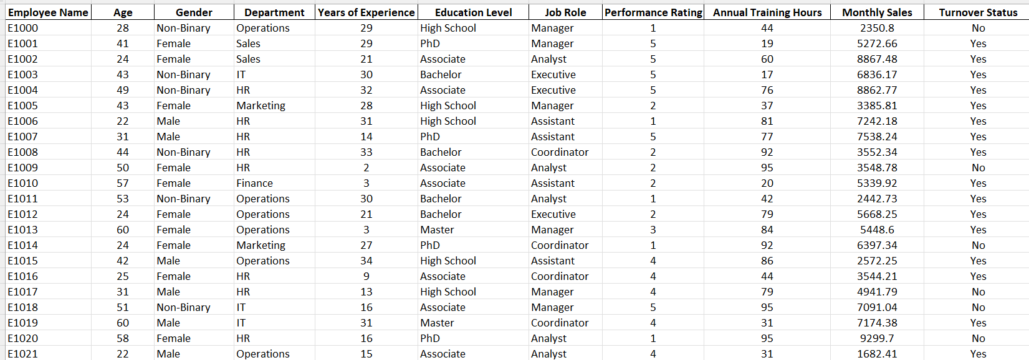

Firstly, here are a visual basic mode system for Log in the form to input new data on the dataset:

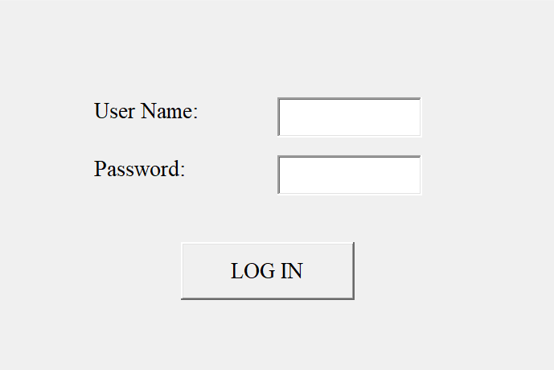

Input form:

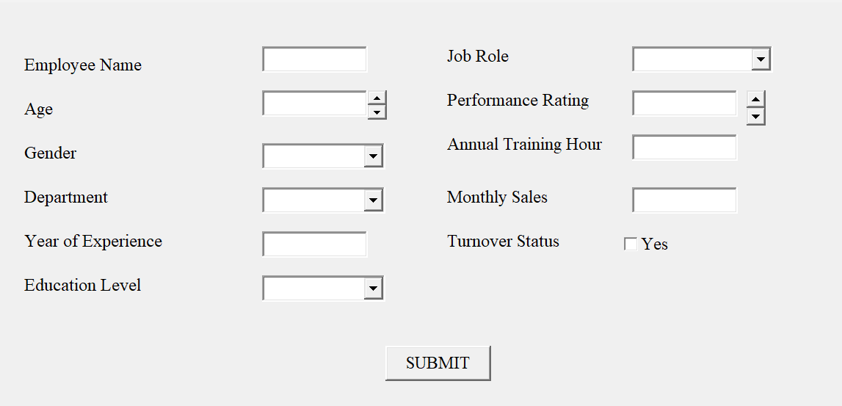

Here, the dataset contains 15 questions here are some sample:

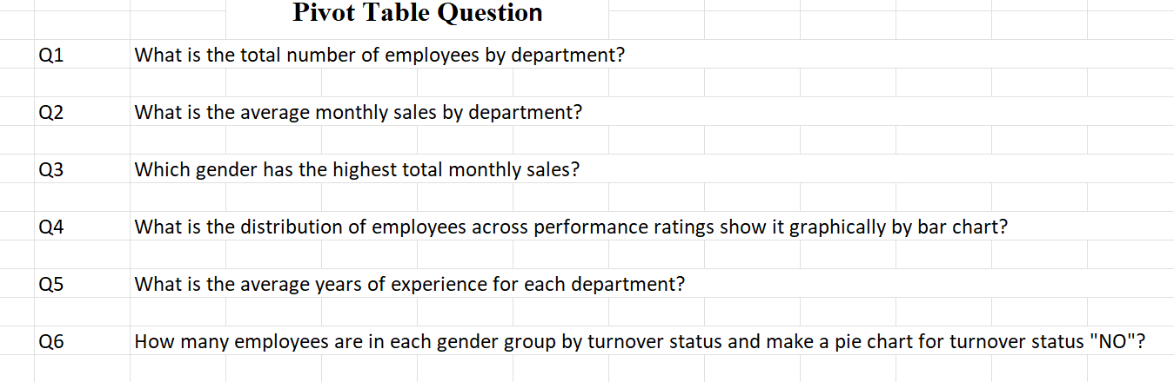

Here, the Question No 01 and the process details:

What is the total number of employees by department and identify which department contain most of the employee?

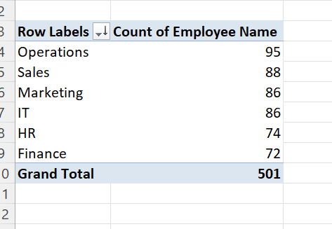

We can see that the relation between department and the employee’s name. Six department contain total 501 employee and Operations department contain of the most number of employee and thar was 95 and the second position department was Sales and it contain 88 employee’s.

Here, the Question No 02 and the process details:

What are the average monthly sales by department present it graphically?

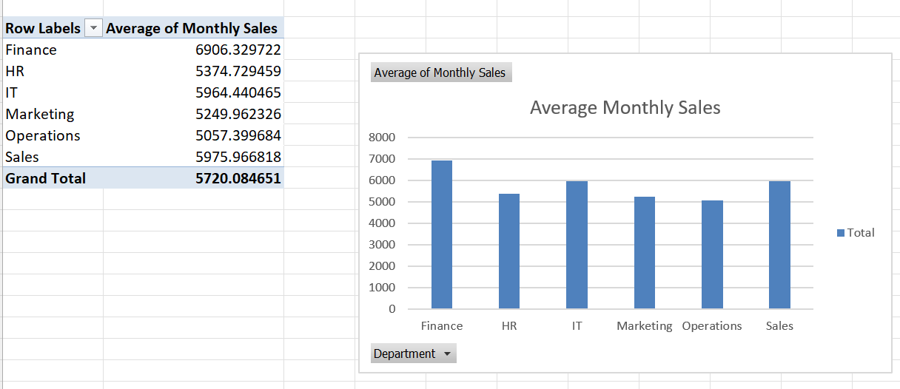

The show thar Finance department provide most average monthly sales and it was 6906.329622. And Operations department provide lowest average monthly sales. Here the total average monthly sales were 5720.084651 for the six department of the employee performance dataset.

Firstly, here the Question No 04 and the process details:

What is the distribution of employees across performance ratings show it graphically by bar chart?

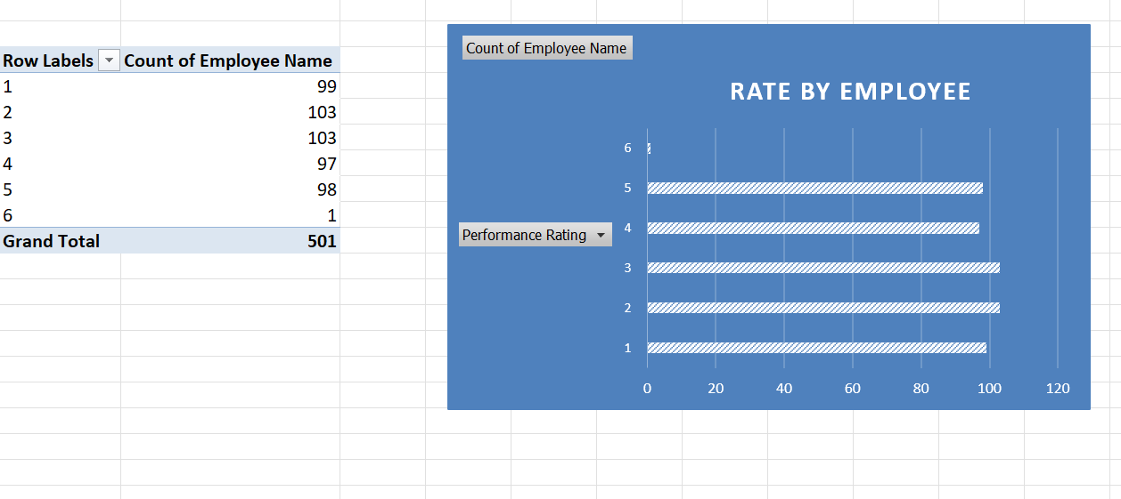

The bar chart shows that the count number depend on the performance rating. When the performance rate was 2 and 3 the employee was highest and it 103 persons. The highest rate was 6 but the employee only 1 person.

Here, the Question No 06 and the process details:

How many employees are in each gender group by turnover status and make a pie chart for turnover status "NO"?

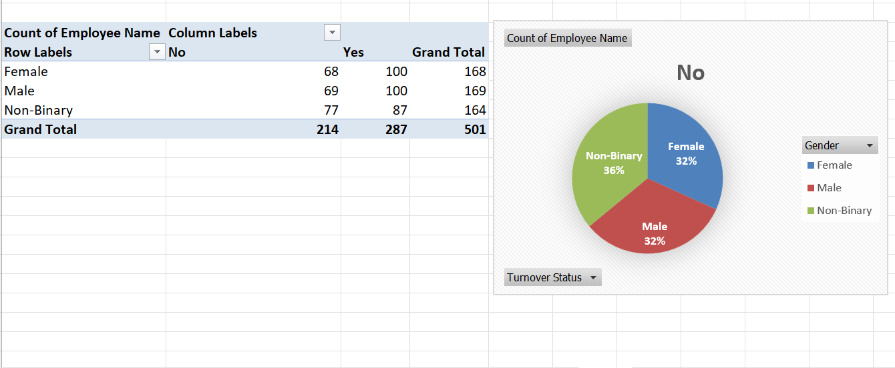

Here the Pie chart show us that only for the turnover status “NO”. Then the Female employee was 32% it means only 68. Male employee was also 32% but the employee was 69. At last, the pie chart describes that the non-binary employee was 36% and the employee was 77 it was the highest rate for turnover status “NO”.

Here, the Question No 7 and the process details:

What are the average annual training hours for employees who left (turnover status = Yes)?

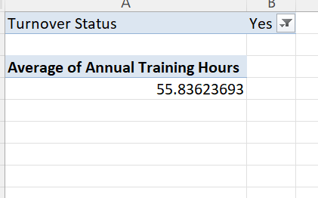

Here we can see that the average annual training hours for employees and their turnover status was yes and the value was 55.83623693

Here, the Question No 9 and the process details:

Which job role has the highest average years of experience?

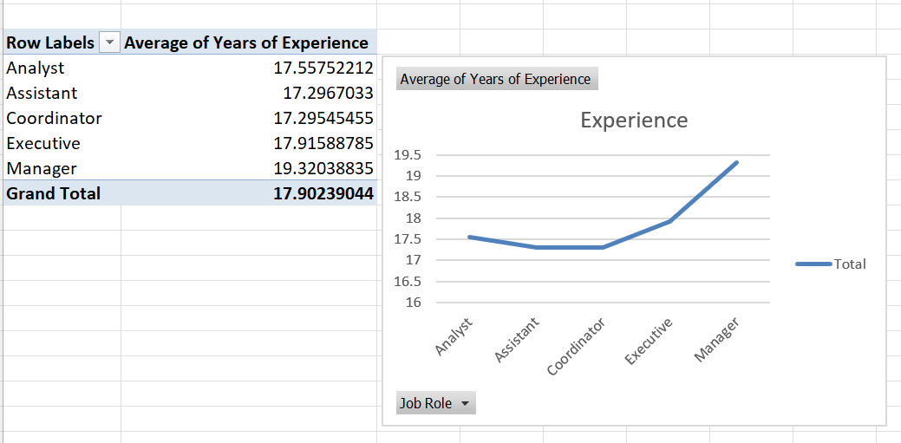

From the dataset, the line chart show that the five kinds of job role for the employee and their average years of experience. Here the coordinator job role has lowest average year of experience and the manager job role has highest average year of experience and it was 19.32038835. The line chart also show that the line is ascending.

Here, the Question No 11 and the process details:

Calculate the Job role vary by Gender show the relation by graphically.

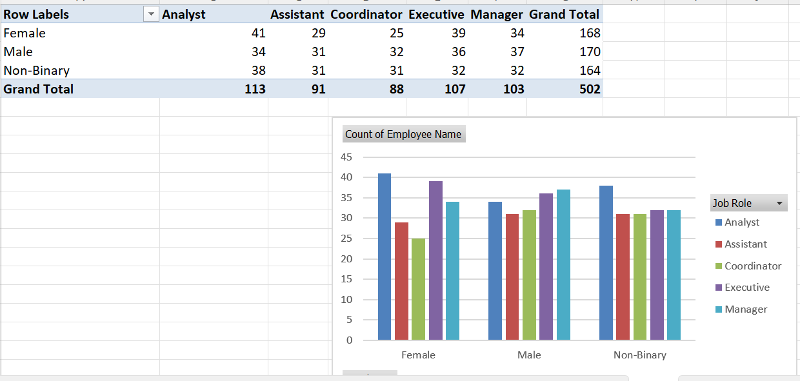

Here the graph shows us that for female the highest employee for the analyst post and the lowest employee for the coordinator post and the number was 25. Secondly for male employee highest for the manager post and the number was 37, the lowest employee for the assistant post and the number was 31.

Here, the Question No 13 and the process details:

How many employees have more than 5 years of experience in each department?

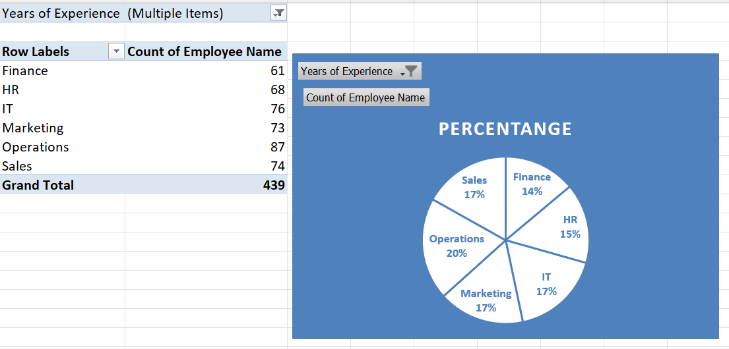

Here the pie chart show that the total 439 employees have more than 5 years’ experience by each department. Here the operations departments employees have more than 5 year’s experiences and the rate 20% the rate was highest. And the Finance department have the lowest rate and it 14%.

Here, the Question No 15 and the process details:

What are the average monthly sales for employees in each age group describe it by area chart?

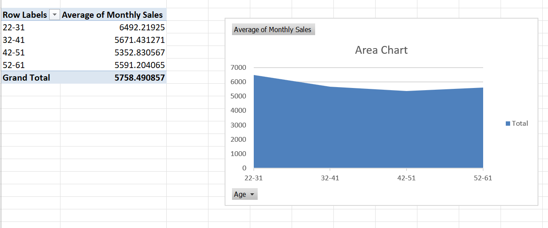

Here the graph describes that the relation between age group and average monthly sales. We can see that the area chart, firstly the age range was 22-31 and the average monthly sales was 6492.21925 it was the highest salary but the next age group we can see that the average monthly sales was reduce gradually. Such as the next group 32-41 ‘s monthly sales low than the 1st group and the age group 42-51 show that lowest average monthly sales from another age groups.

PowerPoint Slide:

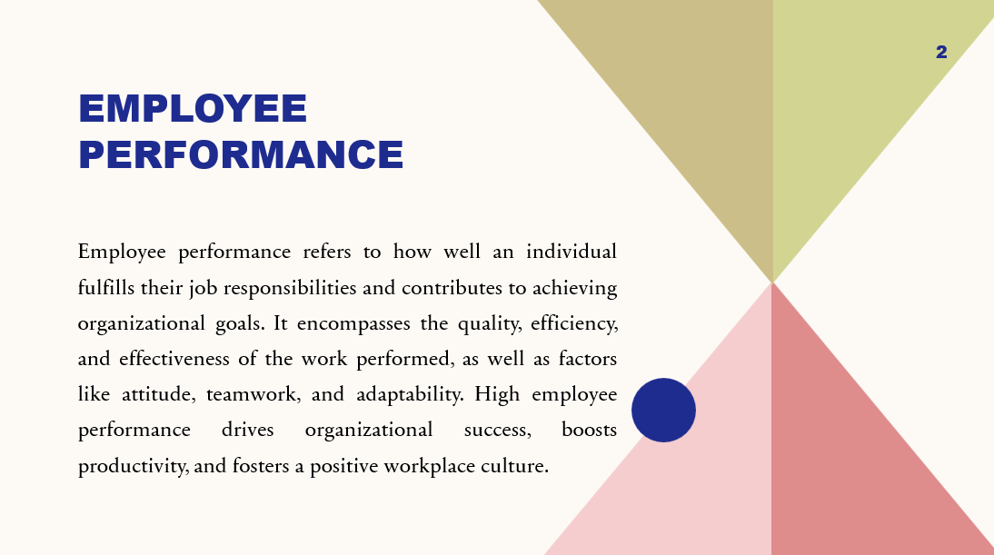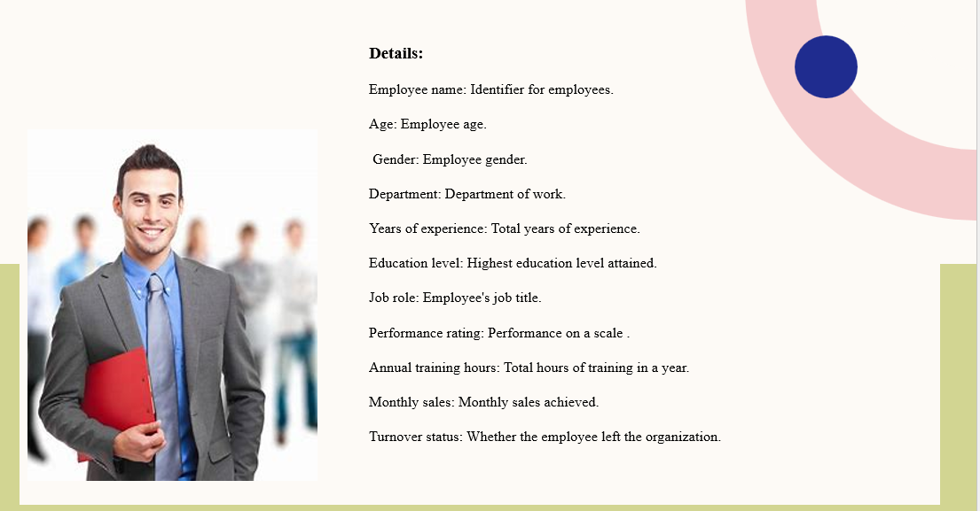

## **Question and Ans**

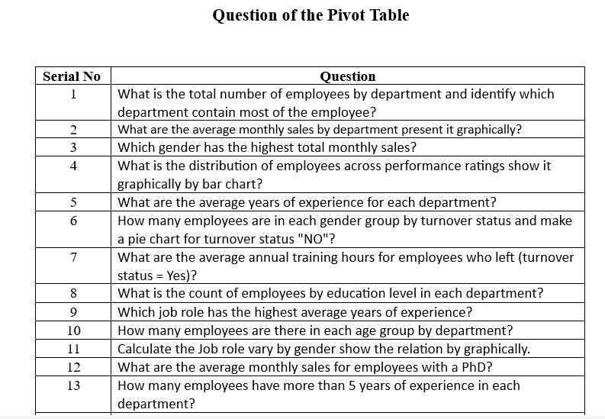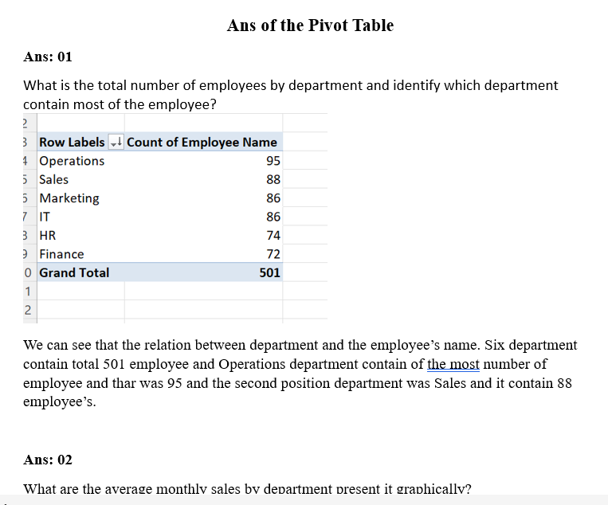

## **Enhancing Performance Rating**

Improving an employee performance rating requires a combination of proactive effort, strategic focus, and alignment with organizational goals. Employees can begin by gaining a clear understanding of their performance expectations. Regularly communicating with their manager ensures alignment on objectives, deadlines, and desired outcomes. This prevents misunderstandings about what constitutes "excellent" performance.

Time management and prioritization are critical. Employees should focus on high-impact tasks and ensure that their work consistently contributes to broader team or company objectives. Learning to delegate non-essential tasks, when appropriate, can also help maintain efficiency.

Skill enhancement is another significant area. Engaging in professional development—through training, certifications, or self-learning—demonstrates initiative and adds value to the organization. Equally important is maintaining a positive attitude, being receptive to feedback, and using it constructively to make improvements.

Building strong relationships with colleagues also enhances performance ratings. Collaboration, open communication, and a willingness to help others foster a supportive work environment, which can reflect well in performance evaluations.

Lastly, employees should take ownership of their work and demonstrate results through measurable achievements. Regularly updating their manager on progress and proactively addressing challenges shows accountability and commitment to success. By combining these efforts, employees can significantly enhance their performance ratings over time.

## **Result**

Average Performance Rating: 3.0

Average Annual Training Hours: 56.4 hours

Average Monthly Sales: $5,758.49

Turnover Rate: 57.17%

## **Conclusion**

Enhancing an employee's performance rating is not merely a product of completing tasks but a reflection of sustained efforts in improving professional competencies, understanding organizational goals, and fostering strong workplace relationships. By maintaining clear communication with managers, prioritizing impactful tasks, and embracing a mindset of continuous learning and adaptability, employees can align their individual contributions with the company’s strategic objectives. Furthermore, cultivating a positive and collaborative attitude while leveraging constructive feedback leads to measurable achievements, which positively influence performance evaluations. This comprehensive approach not only benefits the employee’s professional growth but also bolsters the organization’s overall success.

## **Reference**

ChatGPT.

Google.